All About My Account In Enterprise:

To view and manage your checked out items, holds, and/or fines, log into your account by going to the top bar on any screen in Enterprise:
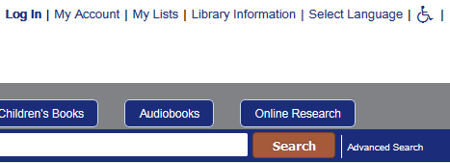

Click “Log In” or “My Account”. Either one will bring up the login box:
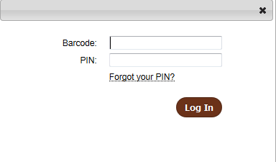

Enter your library card’s barcode, without spaces. Hit ‘Tab’ or click in the field for PIN, and enter your PIN.
If you can’t remember your PIN, you can hover (or click) on “Forgot your PIN?” for a suggestion of the most common PIN number for your account. If you still can’t remember your PIN, please contact your library.
After entering your PIN, click “Log In” or hit Enter. The box will briefly show the text of “Logging in”.

If you have made an error in entering your card number or PIN, the login box will refresh:
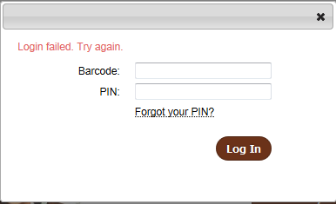

If you have logged in successfully, the computer screen will refresh. If you’ve clicked “Log In”, you will be returned to the screen you were on before you clicked “Log In”. The top bar will then show your name in place of the “Log In” button, as well as an option to Log Out:
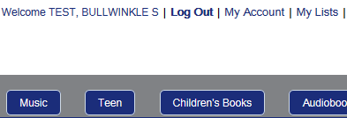

If you clicked “My Account” to bring up the log in box, you will be directed to your account information. Or, once logged in, you can click on “My Account” at any time to bring up your account.
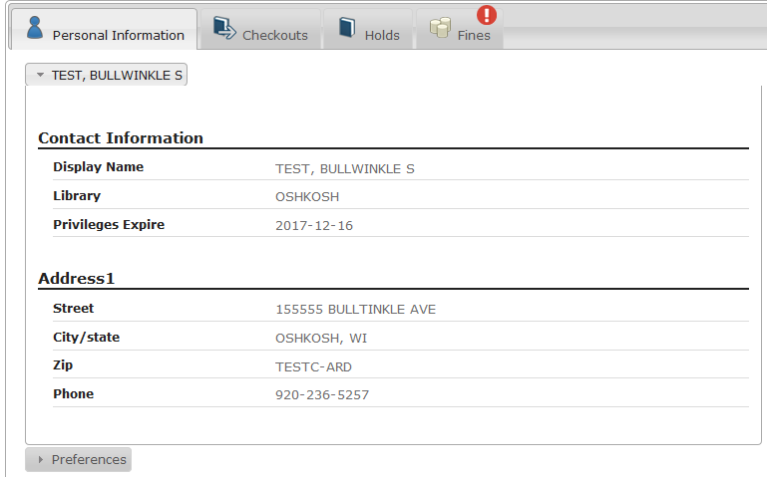

If this is the first time you have logged in, the “Personal Information” tab will be open. If you like, you can choose a different tab to open when you click on “My Account”, so that you always first see what things you have checked out, or what holds you have available, or your current amount of fines.
Click on the “Preferences” tab at the bottom of your address information:
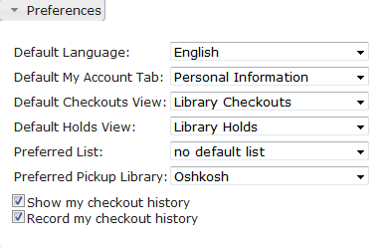

Click on the dropdown box next to “Default My Account Tab”: You can select Checkouts, Holds, or Fines. Or, you can leave the default tab set to “Personal Information”.

On the Checkout tab:
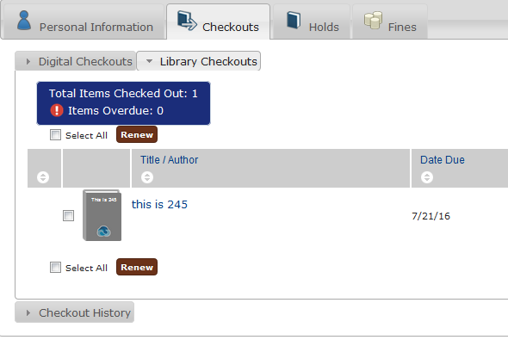

You can view your digital checkouts (eBooks and eAudiobooks through Overdrive), your library materials checked out, and your checkout history.
(On the Personal Information tab, you can select if you want your digital materials or your library materials to be open first when you go to the Checkout Tab, by using the dropdown next to “Default Checkouts View”)

To renew items that are close to their due date, select the checkbox next to each item that you want to renew (Or, if you want to try to renew all items, click the checkbox next to “Select All” located above or below the list of items) and click the brown “Renew” button. A confirmation box will appear:
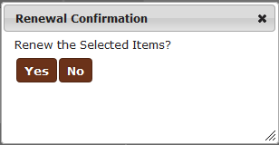

Click “Yes”. The screen will display a circular wait image.

The screen will then refresh.
If the renewal was successful, the item’s due date column will have changed, and the item will, by default, sort by due date to a lower row on the table of items.

THE CHANGED DUE DATE IS THE ONLY INDICATION AN ITEM HAS BEEN SUCCESFULLY RENEWED.

If an item can’t be renewed – either because it has already been renewed the maximum number of times OR if it is from a collection that does not permit renewals (for example, from a library’s Lucky Day collection) – then the item’s checkbox will be grayed out and not able to be selectable for renewals, and red text will show under the item’s author and title:

On the digital checkouts tab, instead of an option to renew an item, if you have not downloaded the item to a device, there is an option to return it before its expiration date.
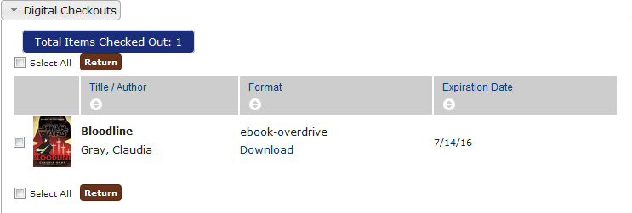

As with renewing an item, check the boxes next to the items you want to return, and click the “Return” button.
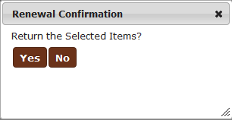
In the confirmation box, click “Yes” if you want to return the item.

The “working/waiting” circle appears:
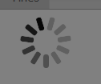

If successful, the item is immediately returned and no longer displays in your checkouts.

The “Download” link on this page opens the eBook in a new tab, to allow it to be read in a browser without downloading. To download to a device, follow the published directions on the Overdrive site, accessible through the Resources page of your library.

If you have requested that your checkout history be saved, or if you select “Show My Checkout History” and “Record My Checkout History” on the Preference tab, you will see a “Checkout History” tab:
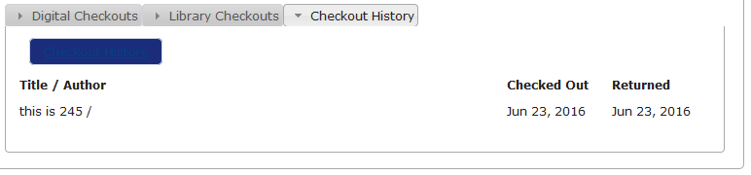

Items will only show on this list after they have been returned.

CURRENTLY, it cannot be sorted. However, this is an issue that will be corrected in another version of the catalog’s software, which is developed by an outside company.

On the Holds Tab:
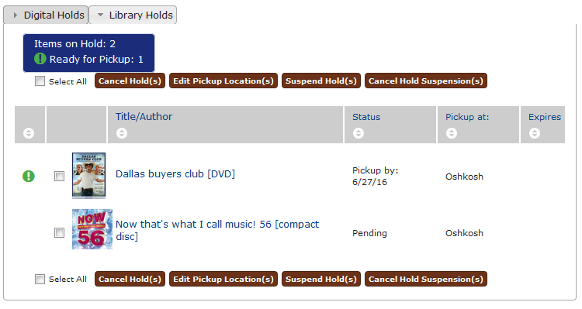

As on the Checkout tab, you can select whether Digital Holds or Library Holds open by default when you click on the “Holds” tab, or if you’ve set it as your default tab when logging into your account. As with the Checkout Tab, this is done through the “Defautl Holds View” dropdown on the Personal Information tab.

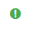
Holds that are available for pickup show a green circle with a white exclamation point to the left of them.

They also show the date that they need to be picked up by before they are automatically canceled.

Items that are not available show a status of “Pending”.

Both items that are available and not available can be canceled by selecting the checkbox to the left of the item, and then clicking the first brown button, “Cancel Hold(s)”:

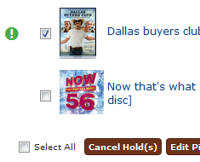

A confirmation pop-up box appears:
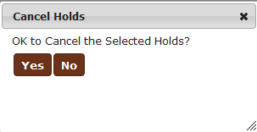

Select “Yes”, and the hold will be canceled.

Both items that are available and not available show the library where they are to be picked up at. This is set at the moment the hold is placed, but if you need to change this to a different library, for items that are not yet available, select the checkbox to the left of the item, and then choose “Edit Pickup Locations(s)”, the second brown button.

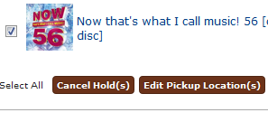

A popup box appears:

Select a pickup library from the dropdown, and click the “Change” button. If successful, this box appears:
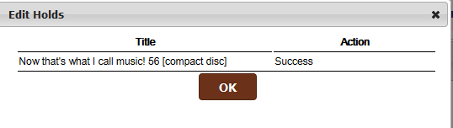

Click “OK” to go back to your holds page.

A hold can be suspended. This is useful if you know that you will nto be available for a known period of time (on vacation somewhere not near your home library), and so would not be able to pick up a hold if it came in. By suspending the hold, you do not lose your place in line, and do not accidentally have the hold expiring because you cannot pick it up.

To suspend a hold, check the holds you want suspended and click the third brown button, “Suspend Hold(s)”:
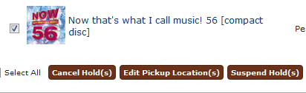’

A popup box appears:
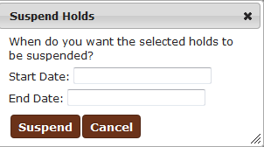

Click on the field next to “Start Date”, and a calendar drops out:
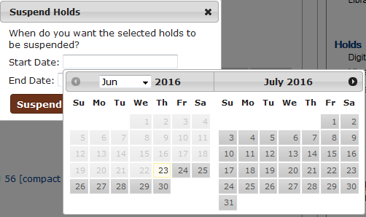

You may select today’s date by default for the Start Date, or, any date in the future.

Once you have selected a Start Date, you can select an End Date for the suspension in the same way, by clicking on the field and selecting a date from the calendar dropout.

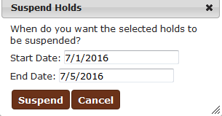
Once you have a Start and End date, you can click the “Suspend” button.

The screen will refresh, and items that have been successfully suspended will show a calendar to the left of their checkbox:
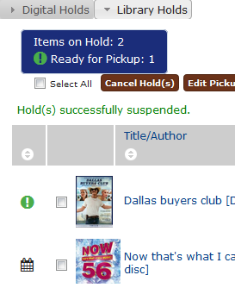
By hovering over this calendar icon, you can see the dates that the hold will be suspended for:

Or, with only the Start Date filled in, you may click “Suspend” without filling in an End Date. This will permanently suspend the hold, from that date forward, until you cancel the suspension. This is useful if you know when you will not be available to pick up a hold, but aren’t sure when you will returning.

A Hold Suspension can be canceled at any time, by checking the boxes to the left of the items and clicking the brown button “Cancel Hold Suspension(s)”:
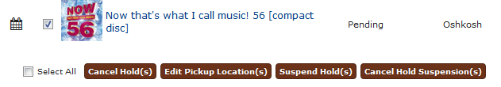

A popup box appears:
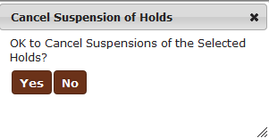
Click “Yes”, and the Hold Suspension will be canceled. If successful, this text appear above the list of holds:
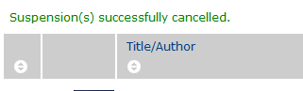

If there are fines on your account, you can see this information on the Fines tab; if you have no fines, this tab will be blank. Also, a red circle with a white exclamation point appears on the upper corner of the tab if there are fines.
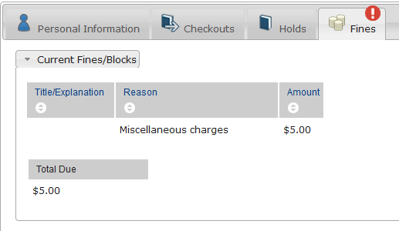

If you wish, you can pay your fines online with a credit card by using the brown button on the right hand summary bar:
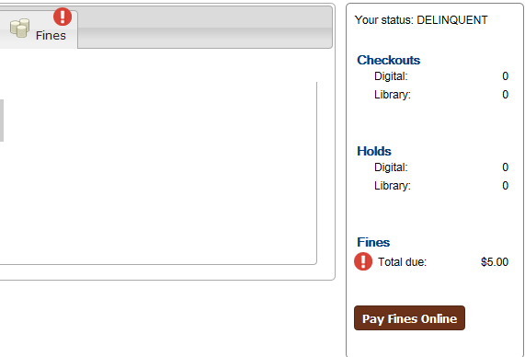

Clicking on the button will open up a new page in a new tab:
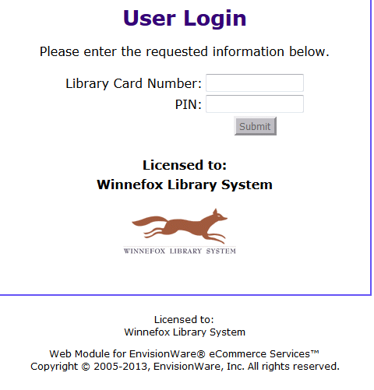

Enter your library card number and PIN, and you will be directed to the form for paying fines online, as in the prior catalog.

